Bahria University,

Karachi Campus



LAB EXPERIMENT NO.

**12**

LIST OF TASKS

|  |  |
| --- | --- |
| TASK NO | OBJECTIVE |
| 1 | **Implement the FIFO and LRU policies described above in C language.** |
| 2 | **Execute both programs for the same set of reference strings. What difference did you**  **observe? Comment.** |
|  |  |
|  |  |
|  |  |

Submitted On:

-June-2022

**Task No. 1: Implement the FIFO and LRU policies described above in C language.**

**Solution:**

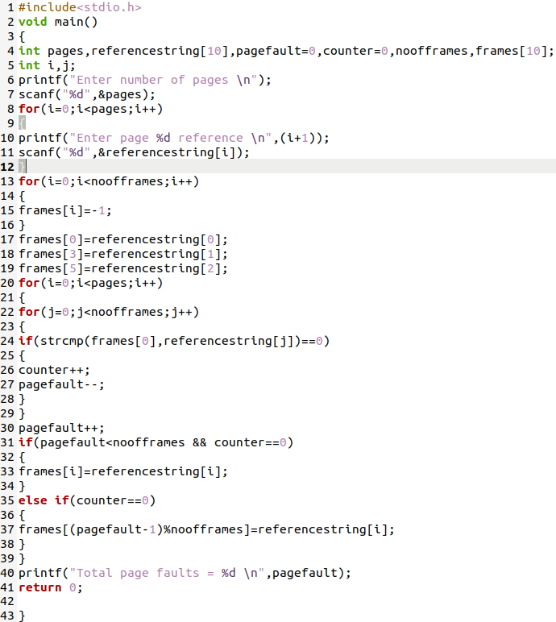

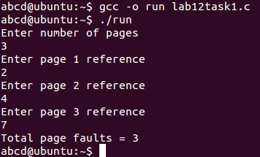

**RLU**

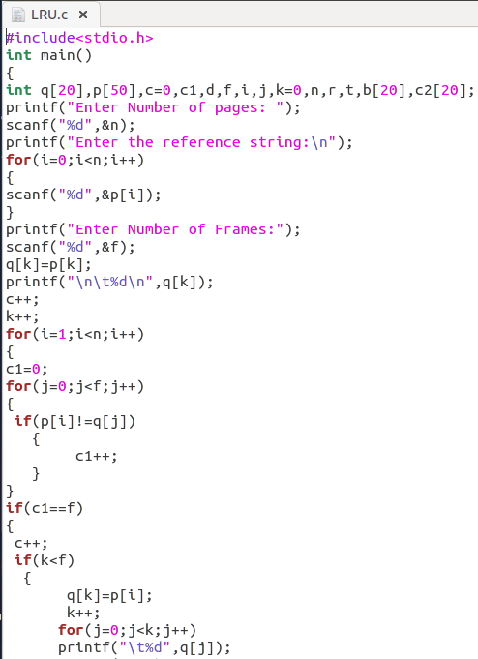

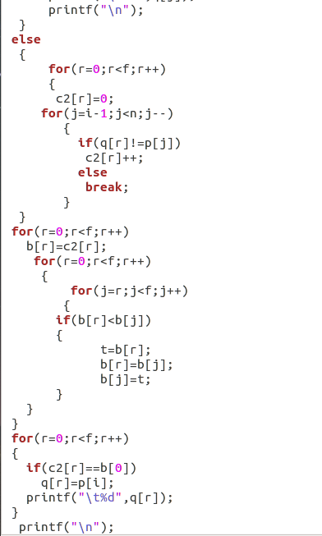

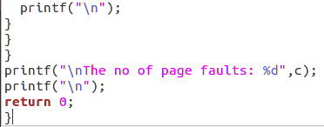

**Output**

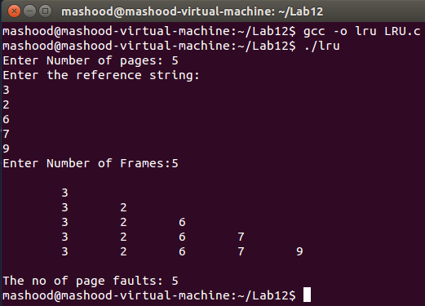

**Task No. 2: Execute both programs for the same set of reference strings. What difference did you**

**observe? Comment.**

**Solution:**

**LRU** means Least Recently Used and the idea of this policy is to replace the blocks less used **in the** cache memory. ... The main **difference between LRU** and **FIFO** is after a hit. **FIFO** does not changes the order of the blocks **in the** cache, **LRU** instead puts the hit block into the newest position.